Where’s the point?

1. The Guardian newspaper measures 92cm by 45cm when opened out. Find the area of the rectangle created, stating the units of the result. Change the measurements to metres, and find the area in square metres.

2. A postage stamp measures 21mm by 28mm. Find the area that it covers.
Change the measurements to centimetres and find the area in square centimetres.

3. A football pitch is 156m long and 92m wide. Find the area in square metres and square kilometres.

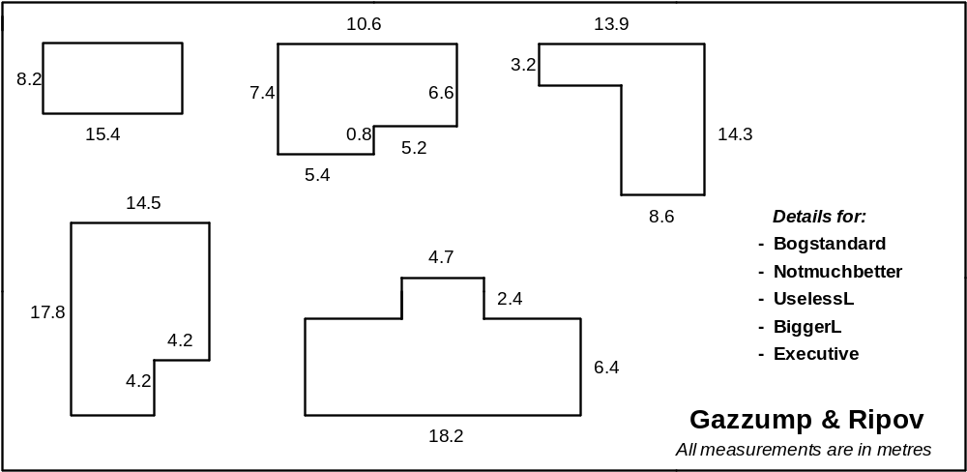4. A London-based estate agent ‘Gazzump & Ripov’ rents out offices based on a fixed rate per square metre of floor space. A company wishes to rent some office space, and is sent the details below. Find the area of each office, stating the units in your answer and showing your methods clearly.

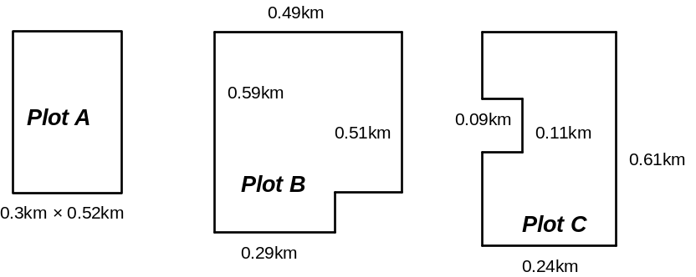5. Builder Bob is starting plans for a new luxury housing development. Any such houses would have to include large gardens. Following planning applications, he is offered the following plots of land:

Find the area of these plots.

Time to spare?
Q1 – How many mm² are these areas?
Q2 – A post office book contains 150 pages of stamps. Each page has 8 rows and 15 columns of stamps. How many stamps? What is the area of a book of stamps in m²?
Q3 – How many cm²? How many mm²?
Q4 – Gazzump & Ripov charge £24.95 per square metre, per week. How much would each office cost to rent per year?
Q5 – Prime building land, this is. £1000 per hectare. What is the cost of each plot?

